ARC 6082

Router Unit Cost Analysis Report

ARC 6098 is a new router unit cost analysis dashboard and report. It will take router yield into account, and show the cost of each sequence as a percentage of the overall cost.

This project is attached to the Estimating / Routing & Quote Management > File > Estimating/Standard Routers > Open > Lines Script 1 button. To access it first select a router on the router master screen and then click Lines.

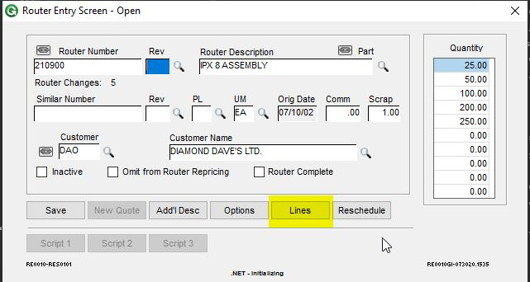

On the lines screen you will see that the Script 1 button has been renamed to “Unit Cost Analysis”. Click this to open the cost analysis in a grid.

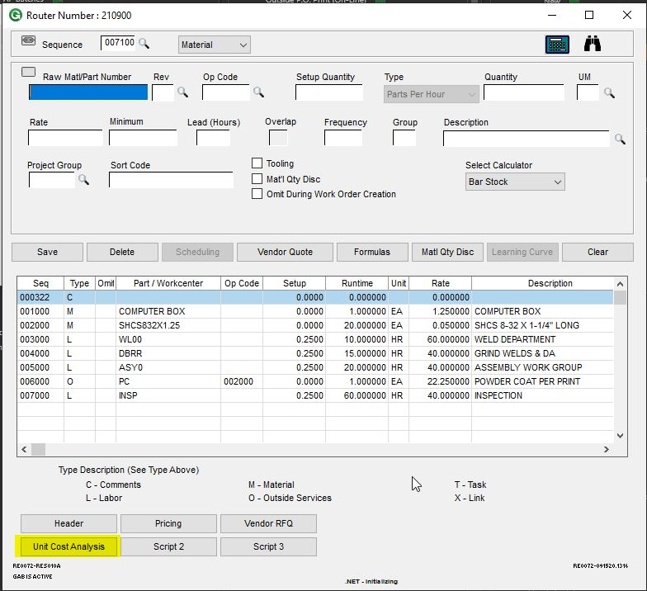

The unit cost analysis will load in the grid displayed below. This has all the standard dashboard functionality, including moving columns, hiding columns, grouping, sorting, filtering, and exporting to Excel.

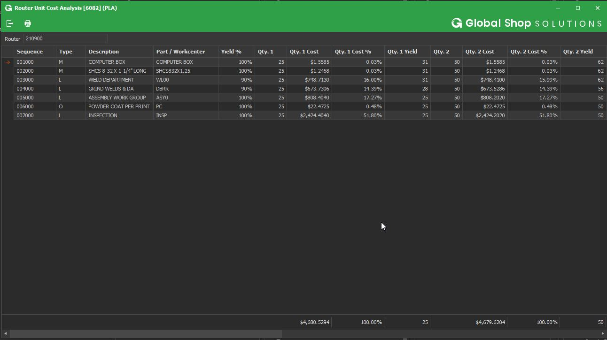

To print the actual report, click the print button in the top left of the screen. The unit cost analysis will print as a crystal report.

